**ENTERPRISE FRAMEWORKS**

**CAR RENTAL WEBSITE**

**CAVAN GAELS**

**Brian Burns x10205284**

**Sean O’Shea x10206230**

**Torsby Attipoe x1112222**

**OVERVIEW:**

Enterprise Framework project to develop a Car Rental System.

Development environment used is the .NET framework

MicroSoft integrated development environment Visual Studio

Architectural pattern used is MVC4

API is REST

**APPLICATION:**

**Car Rental Website**

The purpose of the application is the provision of a web based Car Rental System . The application allows the user to book car hire on line for the rental of cars for varying periods from different locations throughout the country. The application also allows owners of fleets of cars to register their details, upload fleets of cars available for hire, change cars available for hire. The information on Cars, Bookings, Suppliers are all stored in a Relational Database which has been deployed to the cloud. The information stored can be edited, deleted, displayed and searched.

**BACKGROUND RESEARCH & INVESTIGATIONS**

**PROJECT PLAN**

**TaskAnt**

Whilst doing the project we used a web based Repository called TaskAnt. This is a team based tasks web tool which we used to assign, track and search tasks allocated to various members of the team.

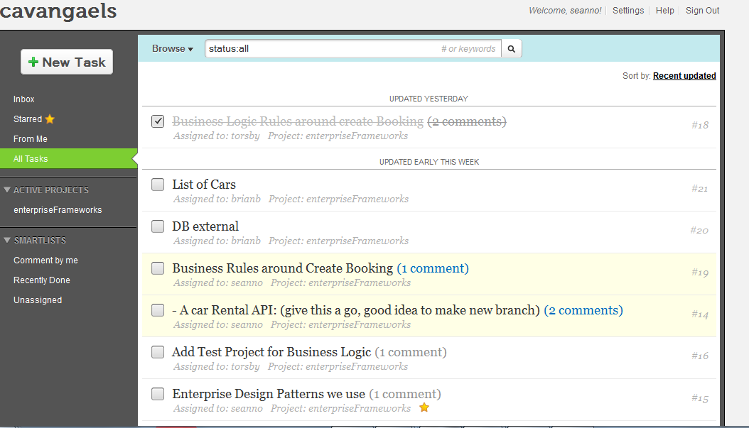

**Git Hub**

We also used **GitHub** which is a web-based hosting service for software development projects that use the Git revision control system. This recorded all the commits and changes to our projects carried out by different members of our Team and allowed us all up to date information on the project as it progressed.

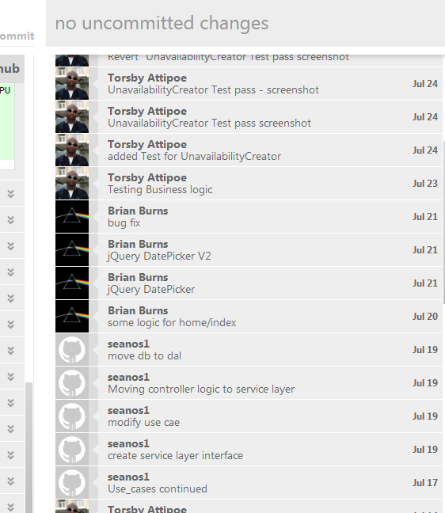

**SOFTWARE DEVELOPMENT METHODOLOGY**

**REQUIREMENTS ANALYSIS**

**USE CASES**

# Use Case 1: User logs on

* User asked to input pickup location
* The user is presented with a drop down box of a list of locations
* The user chooses the location that they require to pick up the car
* User fills out the following details:
  + Pick up date & time
  + Drop off date & time
  + Car Class
  + Email address (optional)
* User Enters Submit Button
* The user is given a report of the number of cars that are available

# Use Case 2: A list of cars available is given from the cheapest to the dearest

* The cars are listed from the cheapest to the dearest.
* The cars are described by the Make, Model and the Number of passengers it can hold & the luggage space.
* The user then selects the car that they want to hire by Select Button
* The user is then given a screen with the details of the car, the location, the pickup and drop off times and the total rental cost.
* The user is asked to confirm by clicking a Button called Confirm
* The user is then re directed to a new page to register their details and confirm the booking

# Use Case 3: User Completes a form giving their Details and are Requested to enter their Payment Details

The customer is requested to fill in a form giving their first name, last name, age, email address

They are then requested to fill in their payment details. Their credit card or debit card.

The user is then required to press a button to confirm the booking

A page is returned confirming the booking

An order confirming the booking is also sent to the car supplier by email

# Use Case 4: Car Suppliers Log in & Report

* Supplier enters login button
* Supplier enters id and password
* The supplier is then returned a page with supplier details. Giving their name address and the number of current cars on the database
* This supplier will include an option to list from the cars available from that supplier & the dates & times the cars are hired from
* The supplier then selects the required options it wants from the report, either a full list of cars or just a list of the confirmed bookings.
* The supplier is then returned a list showing the Registration of the Car, The Car description (name, make, model & colour) & current bookings in the car.
* The supplier also has option to amend car listing.

# Use Case 5: Supplier amends car details by either entering a new csv file of amending an individual car record.

* From car suppliers page while logged in the supplier is given the option to amend the car listing by clicking in a button.
* The supplier is then presented with a drop down listing with options to either
  + Remove a car either temporarily or permanently
  + Replace a car with a different car
  + Add a new car
  + Replace the full list of cars with a new list by updating with a new csv file.

If the supplier decides to remove the car either temporarily or permanently they can change the status of the car to not available or change the status to available

If a new additional car becomes available the supplier can add a record for that by entering the Reg of the car, the name, make model & colour.

* If the supplier chooses to update the car list with a new list he then selects *CSV* from the *Export As* drop-down field
* The user then selects the *Generate Report* button
* The is re-directed to a new page which displays the generated CSV file

**ARCHITECTURE / DESIGN APPROACH**

The architectural design approach used is the layer

**DATABASE:**

The application is using the SQL Express package for visual studio as the database to store the user information.

The data can be created, deleted, edited and retrieved.

**/Permission/SearchIndex**

A dropdown box allows the database to be searched by the cars available for hire in locations..

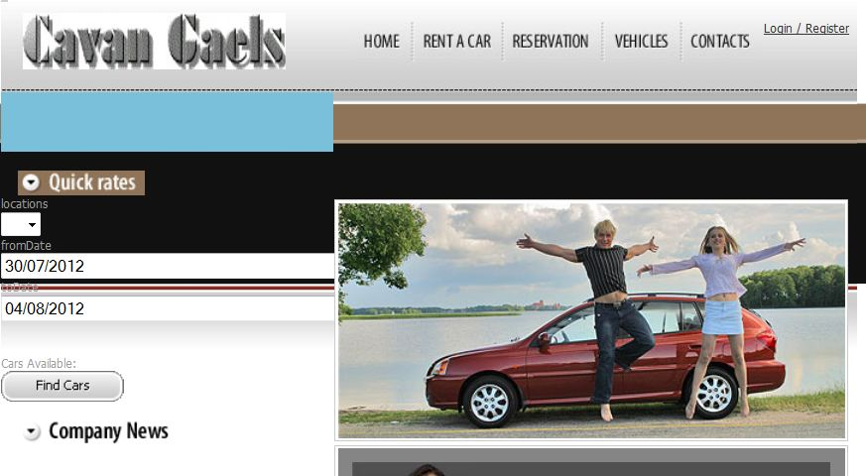

**SEARCHING THE DATABASE:**

The database can be searched by the available cars for hire from a supplier location.

The BookingController sets the search parameters for the SearchIndex View.

**BookingController.cs code to set search parameters:-**

namespace CavanGaelsCarRentals.Controllers

{

public class BookingController : Controller

{

private IServiceLayer logic = new ServiceLayer();

//

// POST: /Booking/

[HttpPost]

public ActionResult Index(LocationsUI requestedTimePlace)

{

BookingUI carList = new BookingUI();

carList = logic.ListAvailableCars(requestedTimePlace);

return View(carList);

}

**Code for dropdown box in the HomeIndex.cshtm View:-**

Database view in visual studio showing user records

The database is stored in the App_Data folder and is called